1.pwd command:

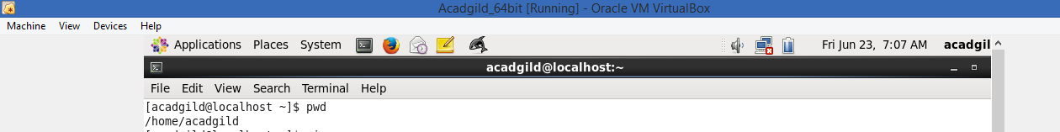

2.vi edit mode:

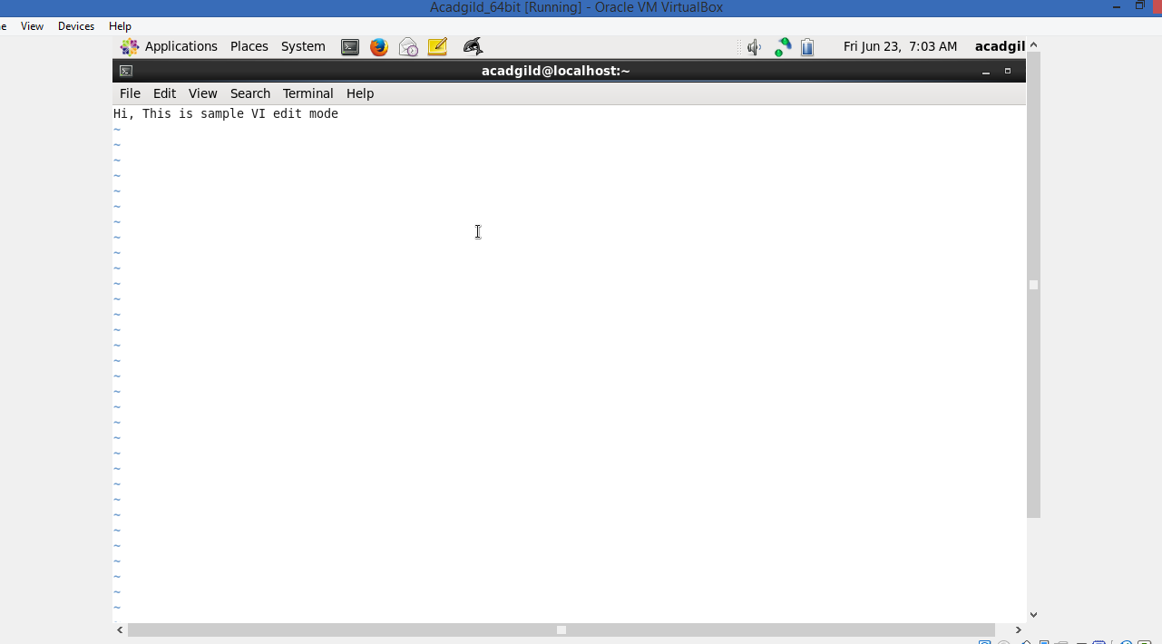

3. touch command:

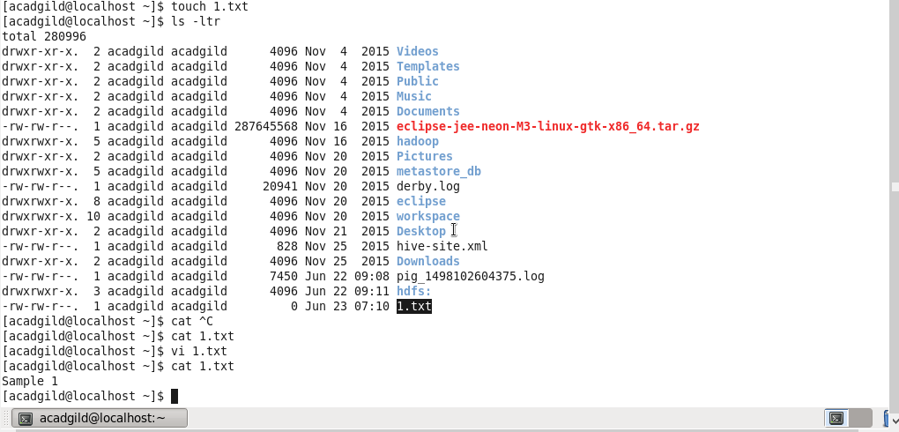

4.mkdir command:

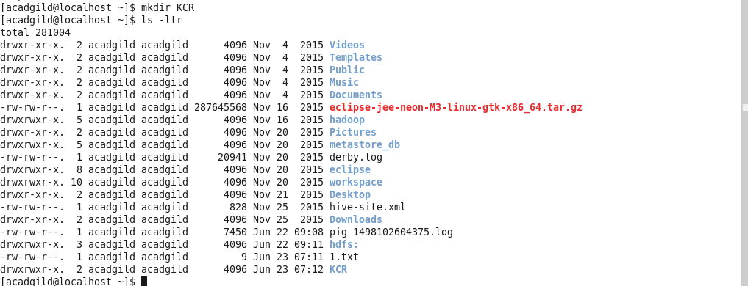

5. rm of the file:

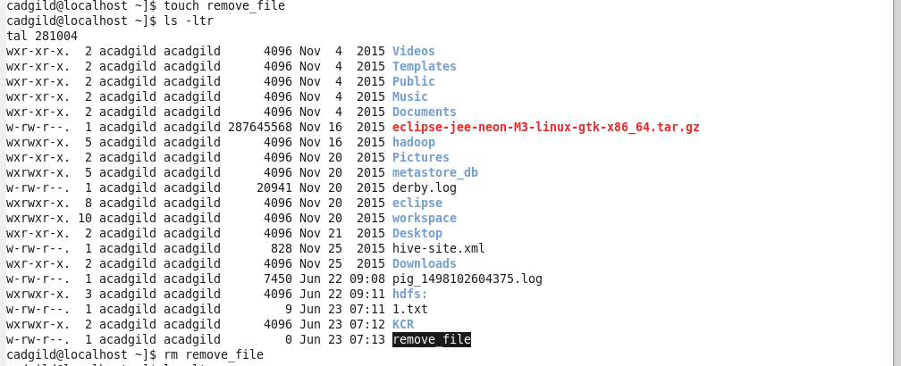

6. ls command:

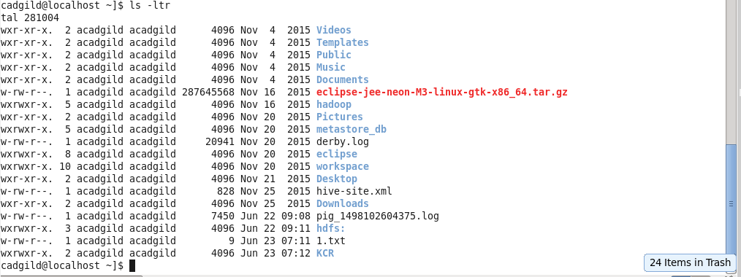

7. echo command:



8. cat command:



9. who command:

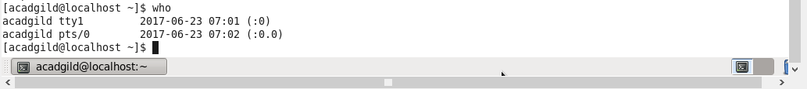

10. pwd command:



11. date command:



12. cal command:

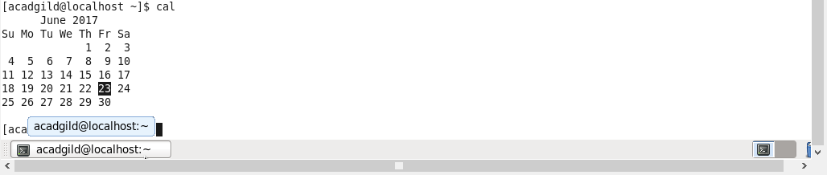

13. mv command:

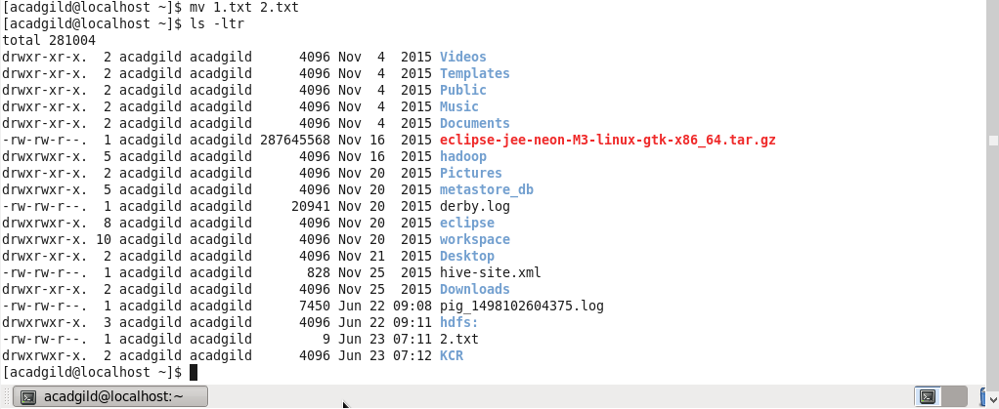

14: copy command:

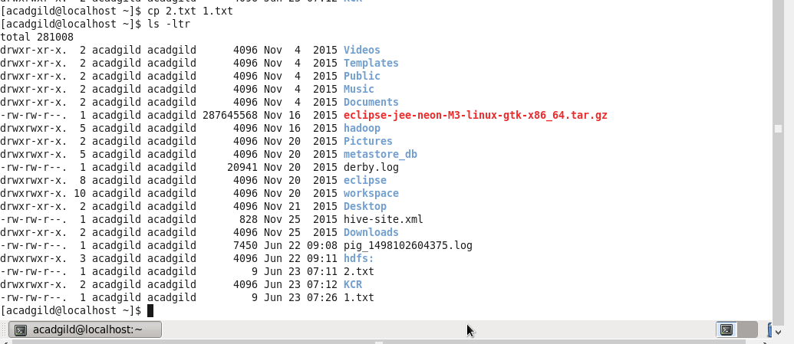

15. which command:

